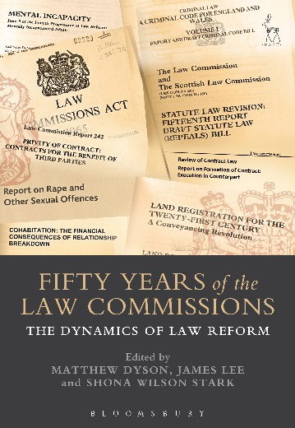
Fifty Years of the Law Commissions
The Dynamics of Law Reform
Edited by Matthew Dyson, James Lee
and Shona Wilson Stark

This book brings together past and present law commissioners, judges, practitioners, academics and law reformers to analyse the past, present and future of the Law Commissions in the United Kingdom and beyond. Its internationally recognised authors bring a wealth of experience and insight into how and why law reform does and should take place, covering statutory and non-statutory reform from national and international perspectives. The chapters of the book developed from papers given at a conference to mark the fiftieth anniversary of the Law Commissions Act 1965.

Matthew Dyson is a Fellow in Law at Trinity College, Cambridge.
James Lee is Senior Lecturer in Private Law at the Dickson Poon School of Law, King’s College London and an Associate Academic Fellow of the Honourable Society of the Inner Temple.
Shona Wilson Stark is a Fellow in Law at Christ's College, Cambridge, and an Affiliated Lecturer at the Faculty of Law, University of Cambridge.

November 2016 | 9781849468572 | 448pp | Hardback | RSP: £95
Discount Price: £76

Click here to order the book – use the code CV7 at the checkout to get 20% off your order

